A program of early learning institute

Wednesday &Thursday Afternoons
1:00-3:00pm $225/month

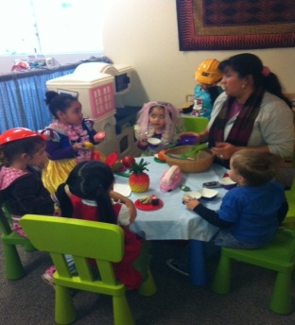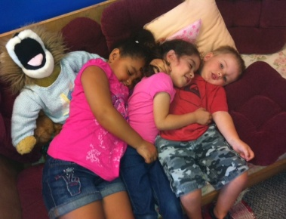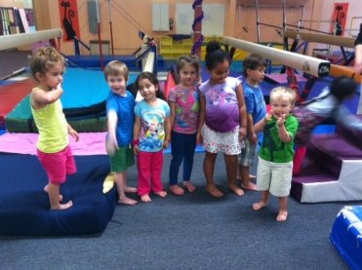
ELI Community Preschool is a small, inclusive preschool play program designed especially for children who are not quite ready for larger preschool environments. Our progressive approach to the early education of children (3-5 years) will provide emergent curriculum based on developmentally appropriate, child-centered interests.
ELI Community Preschool features activities that are rich with opportunities for multi-sensory play, communication, bilingual support and engaging social interactions. Respect for self, others and the environment are stressed with ongoing support around positive social negotiations and environmental awareness activities. Children at ELI Community Preschool are supported by experienced teachers including collaboration with special education consultants, language specialists, occupational therapists and physical therapists. We embrace a philosophy of celebrating children with diverse backgrounds and learning styles. Our ultimate goal is to provide a fun and meaningful early education experience for children within a safe and inclusive environment where all children can be successful.

For registration information, please contact Pat Boblitt or Kelly Burt at
Early Learning Institute 707-591-0170
patb@earlylearninginstitute.com or kellyb@earlylearninginstitute.com
or Apply online at: https://www.earlylearninginstitute.com/preschool-application

Application for Academic Year 2024-2025

I am applying for: Wednesday/Thursday 1:00-3:00 pm _____

Child’s Name ______________________________________Birthdate ____ /___ /___
(Child’s nickname __________________________________)

Home Address__________________________________________________________________

City __________________________ State _______ Zip code ______________

Parent/Guardian Name __________________________________________________________
Address (if different than above) ___________________________________________________
Home Phone#____________ Cell# ____________E-mail _______________________________

Parent/Guardian Name __________________________________________________________
Address (if Different) _____________________________________________________________
Home Phone#_____________Cell#_____________E-mail_______________________________

Home Language(s) _______________________________________________________________

After carefully considering each application for the purpose of balancing age, siblings, needs of the families and children, a group of children will be selected.

Agreement

Hours and Fees
I, _____________________am contracting with Early Learning Institute’s ELI Community Preschool for my child, ___________________ birth date ________

Terms of our agreement are as follows:

ELI Community Preschool serves children between the ages of 36 months until entrance to Kindergarten. No child will be refused enrollment because of gender, race, religion, or that of their parents. Enrollment in this program also requires parent participation in:
* Parent Education/Information meetings
* Scheduled Snack Provision
* Parent Teacher conferences
* 6-8 volunteer hours

This contract is valid beginning _____________________ through the end of the school year.

ELI Community Preschool is currently offering to serve children in the afternoon: a 2-days/week
program. Your child will be enrolled for the tuition fee of $ _ per month.

Tuition statements will be emailed monthly. Payments may be made online or in-person by cash or credit/debit card. Payment will be due on the 5th day of each month. There is no credit given for holidays or days absent due to illness, vacation or otherwise.
-Please make arrangements ahead of time for circumstances that require your payment to be late, otherwise payments after the 5th will be considered late and will be charged a $5 per day late fee.

Your contract remains in effect until ELI Community Preschool receives 2 weeks written notice of your intention to change or cancel your contract before the close of the school year. ELI Community Preschool will not grant tuition refunds if leaving before the end of the month. ____ (initial)

Your child must be signed in and out daily with initials of an authorized adult. Your child will not be released to anyone not on your authorization form or emergency form. If late pick-ups become a challenge for staff, a late pick up fee of $10 for every 15 minutes after school is closed will be instituted. ____ (initial)

I have read the above terms of enrollment and agree to abide by them.

________________________________________ _________________
Parent/Guardian Signature Date
Confirmed by Staff: ____

Emergency Record

Child’s Name____________________ Birthdate__ /__ /__

Address __________________________City _____________________ Zip Code ___________

Parent/Guardian Name ___________________________ Home #/Cell# __________________
Place of Employment ____________________________ Work Phone __________________

Parent/Guardian Name ___________________________ Home #/Cell# __________________
Place of Employment ___________________________ Work Phone# __________________

Person to be contacted in the event of an emergency when parent cannot be reached

______________________________________________________________________________
Name Address City, State, Zip code
______________________________________________________________________________
Home phone Cell phone/work phone

Child’s Doctor _______________________ Address__________________Phone_____________
Child’s Dentist _______________________Address __________________ Phone____________

Does your child have any allergies? If yes, please describe
____________________________________________________________________________________________________________________________________________________________

Does your child have any special needs or other health considerations? If yes, please describe
____________________________________________________________________________________________________________________________________________________________

Medical Release: I ___________________, hereby give my permission to ELI Community Preschool to call a doctor for medical or surgical care for my child __________________ should an emergency arise. It is understood that a conscientious effort will be made to locate me or my spouse ______________________before any action will be taken. It is understood that if it is not possible to locate us, this expense will be accepted by me.

__________________________________ _____________________________
Parent/Guardian Signature Date

Persons Authorized to Pick Up My Child

Child’s Name______________________________________________

Only the people listed below (with photo id) will be able to pick up your child

Name_________________________________________________________________________
Relationship Phone numbers

Name_________________________________________________________________________
Relationship Phone numbers

Name_________________________________________________________________________
Relationship Phone numbers

Name_________________________________________________________________________
Relationship Phone numbers

________________________________________ _________________
Parent/Guardian Signature Date

Media Consent Form

I, (parent/guardian) ___________________________ give my consent to The Early Learning Institute to photograph and/or videotape my child, for the purpose of display, educational training and/or advertising (i.e.: brochures, articles, etc.). I understand that if at all possible, I will be informed prior to any media usage or event, and will have final approval or denial of my child’s participation. I further understand that this agreement in no way obligates me to reimburse The Early Learning Institute for any costs incurred nor does it entitle my child or me to compensation. This consent will remain in effect until notification is given to the Early Learning Institute to no longer use any images on file.

_________________________________ _____________________
Parent/Guardian Signature Date

Family Questionnaire
(Please feel free to use the back of this form to complete your answers)

For _____________________ (Child’s Name)

- How would you describe your child’s temperament?

- What kinds of things is your child interested in doing? Exploring? Playing?

- How does your child cope with situations that are difficult for him or her? What comforts your child during stressful times?

- Does your child have any fears we should know about?

- What are your child’s favorite foods?

- Are there any special family celebrations or traditions you would like us to consider sharing in the classroom?

- Is your child attending any other preschool and/or receiving any additional support services?

IMMUNIZATION RECORD NEEDED

First Name __________________________ Last Name _______________________
Date of Birth ___ / ___ / ____
The California School Immunization Law requires that children be up-to-date on their immunizations (shots) to attend a childcare, day nursery, nursery school, family day care home, or development center, OR have a medical exemption. Diseases like measles spread quickly, so children need to be protected before they enter. If a licensed healthcare provider determines a vaccine should not be given to your child because of medical reasons, a written statement from that provider will be necessary.
A personal belief exemption is no longer an option for entry into any group program or preschool class at eli. For complete details, visit ShotsforSchool.org, or contact your local health department (bit.do/immunization).
To attend the Early Learning Institute facility and eli Community Preschool, eli needs to know that your child’s immunizations are up to date, or that there is a medical exemption in place. You can supply a copy of your child’s “yellow card”, an immunization record sheet from your healthcare provider or a copy of the exemption.
THE LAW:
Health and Safety Code, Division 105, Part 2, Chapter 1, Sections 120325-120380; California Code of Regulations, Title 17, Division 1, Chapter 4, Subchapter 8, Sections 6000-6075

Parent/Guardian Name (please print)

Parent/Guardian Signature Date

COVID-19 RELEASE AND WAIVER OF CLAIMS (“Release”)
The undersigned, in my capacity as parent or legal guardian, hereby acknowledge they have been informed of the health risks and dangers associated with the transmission of the COVID-19 virus, and other communicable diseases, and recognize that exposure to the COVID-19 virus, or other communicable diseases, while unlikely, could occur if my child participates in-person in an Early Learning Institute Program.
All ELI employees follow strict health protocols to ensure the health and safety of all clients and their families. Masking, social distancing, temperature checks, environmental cleaning and other attempts to mitigate risk are all part of program delivery until further notice.
As such, and in consideration for the services to be provided by ELI, the undersigned, for myself and my minor child(ren), acknowledge that virtual program supports have been offered in lieu of in-person services and I have chosen to receive at least some of my services in-person. (In-person services may be offered outside, at an ELI center playroom or another mutually agreed upon site.) Therefore, I fully assume all of the risks associated with participation in the Program, including the possibility of COVID-19 (or the novel coronavirus) community spread, for myself and my minor children.
I, AS PARENT AND/OR LEGAL GUARDIAN, HAVE READ (OR HAD READ TO ME) THE CONTENTS OF THIS RELEASE AND AGREE THAT I AM VOLUNTARILY WAIVING, RELEASING, INDEMNIFYING AND DISCHARGING THE EARLY LEARNING INSTITUTE (ELI), ITS DIRECTORS AND EMPLOYEES FROM ANY AND ALL LIABILITY, DAMAGES, AND EACH AND EVERY ACTION (COLLECTIVELY, “CLAIMS”) BY PARTICIPATION IN AND/OR ASSOCIATED WITH THE PROGRAM INCLUDING, BUT NOT LIMITED TO EXPOSURE OR TRANSMISSION OF THE COVID-19 VIRUS.
I represent that I have full authority to sign on behalf of my child(ren) and that my signature binds each other person having authority to make decisions on behalf of the child(ren).
MY SIGNATURE BELOW IS CONFIRMATION THAT I HAVE READ AND FULLY UNDERSTAND AND ACKNOWLEDGE THE CONTENTS OF THIS RELEASE.
Parent/Guardian Name (please print)

Parent/Guardian Signature Date
Child(ren) Name(s):

